@JohnDanaher 9:29 AM · Apr 26, 2024

Fascinating new paper from @SvenNyholm on the effects of gamification on agency and responsibility. While many people have discussed the ethics of gamification, Sven addresses a neglected aspect of it https://link.springer.com/article/10.1007/s11023-024-09661-5

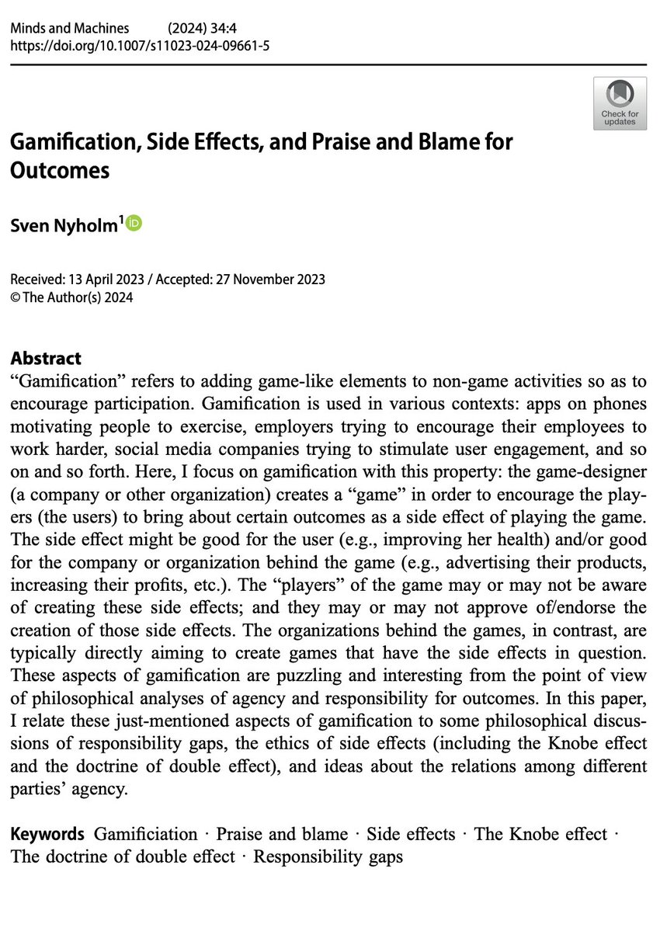

@SvenNyholm

Thanks John! Listeners of our This is Technology Ethics podcast might recognize the discussion of the ALS ice bucket challenge example that we discussed in some detail in one of our episodes

@JohnDanaher

As @SvenNyholm points out, some related themes are covered in episode 4 of the This is Technology Ethics Podcast: technologyethicspod.wordpress.com

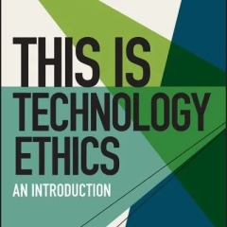

*4 – Behaviour Change and Control*

*In this episode, John and Sven talk about the role that technology can play in changing our behaviour. In doing so, they note the long and troubled history of philosophy and self-help. They also ponder whether we can use technology to control our lives or whether technology controls us.*

@rodakker (Rieks op den Akker)

Isn't this what typically happens in open markets?

@PabloRedux Apr 28

It is fascinating, but... as a free-will-sceptic generally adopting a games perspective on human behaviour, I seem to have a stultified view! What am I to make of "praise and blame" or "non-games activities" - or even "side effects", when effects are always relative to observers?

I didn't realise (in my usual ignorance, as Pablo the Unread) that Bernard Suits, as well as 'What is a Game' had also very astutely written 'Is Life a Game we are Playing?' The first column here is useful in relation to lack of awareness of games we may be participating in...

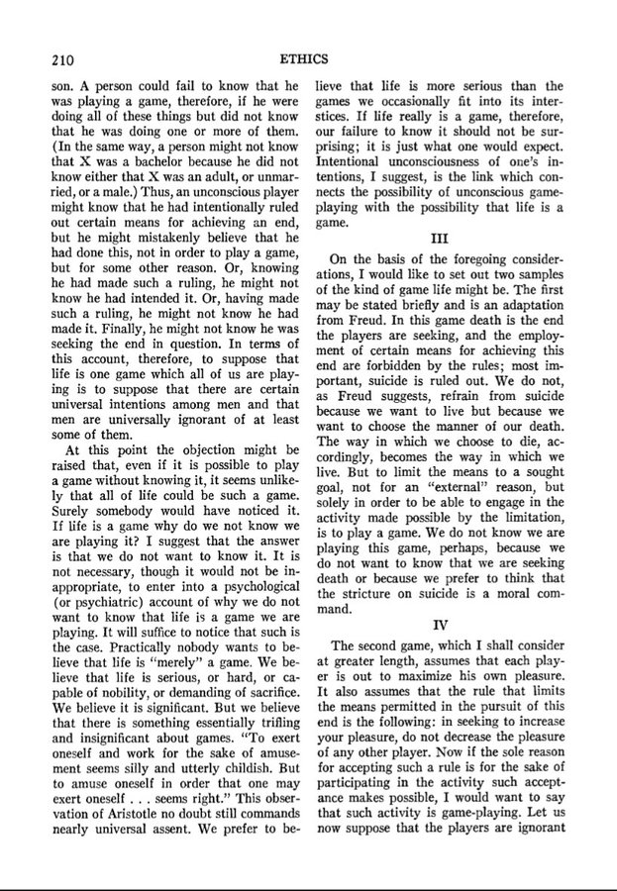

Anyway, I still think I roughly guessed right about Suits here? (In yet another unfinished essay, The Last Post, from 4 years ago.) @david_gunkel @JoshGellers

|  |
| --- |
| The philosopher Ludwig Wittgenstein used the idea of "family resemblances" to explain - or investigate - how words we all use easily become hard to pin down to everyone's satisfaction. I find I've actually been paraphrasing him above without knowing it, so who am I to disagree with myself? First he says that language is woven into our actions as a kind of game, the "language-game". But then (he really was as contrary as Ray Davies) he denies the word "game" itself has a definition beyond dispute: elements, characteristics, similarities simply crop up and disappear, so that games form a recognisable family with many common features but never a definitive set. However, a younger rival, Bernard Suits, accepted the dare and replied, no doubt sticking out his tongue, "playing a game is the voluntary attempt to overcome unnecessary obstacles" by means of rules intended for that purpose. This is a very cunning reply which certainly had me fooled. I think the trick is, though, once we start prodding round the edges of this thought, it begins to emerge that everything - life itself - is a game and because we invariably fail to notice it's begun without us, we're obliged to pick up - and sometimes reinvent - the rules as we go along. Which may have been Ludwig's point. It's almost certainly been my strategy in these essays - and I should know.  I should know... but I've been wrong before about what I've written, haven't I? |

@suspendedreason Apr 30

I've always disliked this definition, but perhaps I misunderstand it

To me, a game crops anytime you have an agent in an environment (ie always)—an agent (by definition) has goals; the goals transform the environment perceptually into instruments and obstacles.

But curious to hear dissenting opinions if held

@PabloRedux

Sounds reasonable but I'm wary of "by definition" and I think with different hats on, through alternative sets of glasses, sitting at nearby tables, we may talk in various ways about such kinds of thing. Also, I appreciate the futility of having to be "unnecessary"!

@suspendedreason

well, what's an agent without goals?

I agree with you about hats/glasses/tables. I guess I was hoping to understand "unnecessary," because I haven't been able to!

I think yr right re effect v side- in eye of observer—

But in similar spirit, is anything in this world necessary?

@PabloRedux

Does a chemical agent have goals? I guess it can't help its natural drives.

It is off-putting that unnecessary obstacles turn out to be necessary for a game (especially given everything's a game), but seems they're unavoidable! <https://etymonline.com/word/necessary>

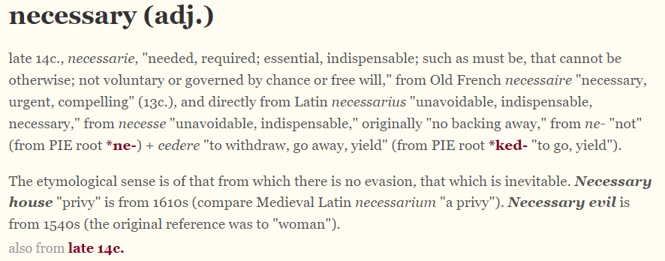

@PabloRedux Apr 28

I haven't read The Grasshopper either, which is several years later, but maybe - from this excerpt to the intro by Thomas Hurka - Suits simply chose not to resolve the issue? (Although it doesn't follow that Wittgenstein didn't fail to resolve some of his own problems.)

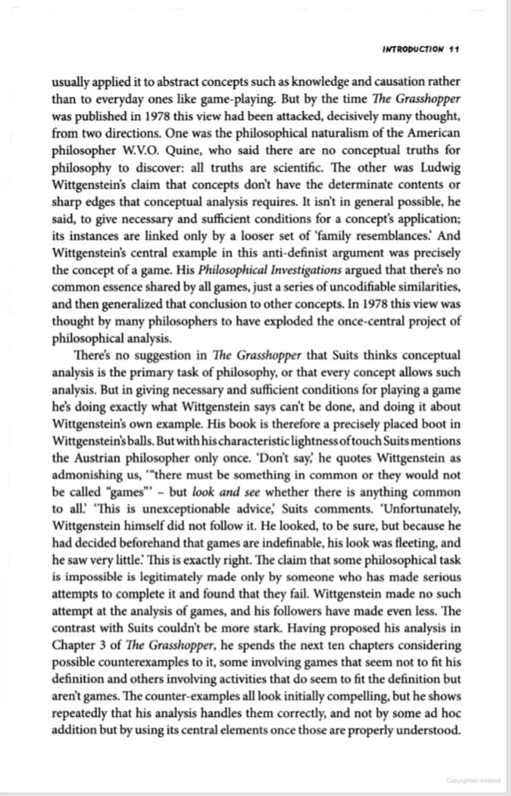

I think the issue is here (near the end of 'Is Life a Game...'): the idea that a genuine distinction can be maintained between treating "as if" and "really being" in naming goings-on. It may be a rule Suits has adopted, in order to trump Wittgenstein, or just happens to follow?

VI

It should be clear from these consider- ations that I am not arguing for the possi- bility of viewing life as though it were a e game. My purpose has been, rather, to set out the conditions for life's really being a game. Recommendations that things be - viewed as though they were other things are usually made in the interest of some I kind of utility. Thus Kant points out that

Anyway, if everything (circularly) is a game, then e.g. transport infrastructure and car adverts are; and the "medium is the message/metaphor" is better read as "the game is the game", in which we are continually diverted into accepting the games (and effects) of private cars.

May I suggest that my stance https://twitter.com/PabloRedux/status/1784497501397029332 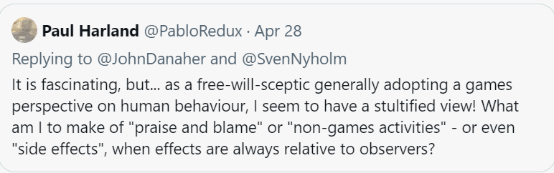

could even open up the discussion rather than disabling it? But it may complicate it. @add_hawk says, "When a person plays a varied diet of games, they will have exposed themselves to many different modes of agency."

Incidentally, with ref to that paper, I bet Suits could easily choose, in his definition game, to argue that interactive narrative games do feature unnecessary obstacles, as it's actually a common narrative principle, e.g. https://scriptmag.com/features/use-of-story-obstacles

Hmm, maybe it's not incidental, Wikipedia https://en.wikipedia.org/wiki/Game_studies says there's a major debate about narratology vs ludology. (My knowledge is limited to vague memory of Bartle's taxonomy of player types.) The article doesn't mention "performativity" or similar drama perspectives?

As a (I don't know) fictionalist pluralist actually-rather-not-be-an-ist, I'd rather allow for multiple perspectives, not of equal but comparable validity. Concepts approximate to events across multiple dimensions, blah blah blah. I find my present view both useful & frustrating.

Intermission...

*Quote: @tscottphillips (Thom Scott-Phillips)*

*Increasingly I feel that academics self-organise themselves not primarily by 'topic of interest' but rather 'epistemology'.*

*Different fields and subfields have different assumptions about what is useful knowledge and how it is acquired.*

*Further, these assumptions often go without saying.*

*This has the effect of pushing away newcomers who may be interested in the topic but who have different epistemological assumptions.*

*And I think this is bad for everybody.*

*Quote: @cogscikid (Wilka Carvalho)*

*I would go one step further and say that fields (and departments) organize themselves by their epistemological *values\**

Intermission... 'What is the virtue of “perspectivism” if it simply amounts to a dogmatic attachment to its own rejection of dogma? Opponents usually present this challenge in the form of a dilemma: is perspectivism true, or just another perspective?' <https://3quarksdaily.com/3quarksdaily/2011/11/more-about-pluralism-and-perspectivism.html>

@David_Gunkel

"Perspectivism" is a concept introduced and developed by Eduardo Viveiros de Castro in his anthropological work with Amerindian cosmologies. For my money, this is still one of the best--if not THE best--formulations that is available in print. <https://doi.org/10.2307/3034157>

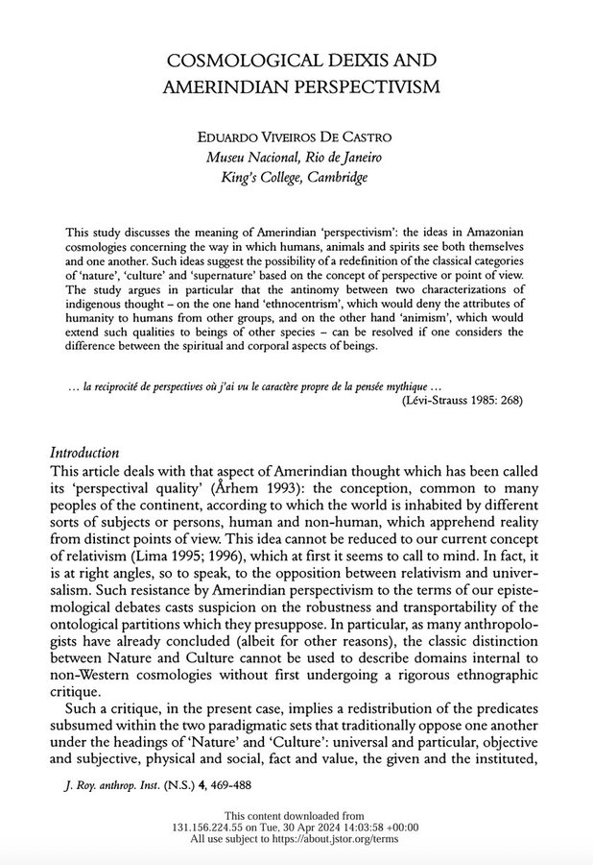@PabloRedux

@PabloRedux

Thanks - well, it gets off to a good start by being interested in an outside perspective!

@David_Gunkel

No pun intended : )

@JoshGellers

The virtue is that is the antithesis of epistemic and ethical imperialism.

@PabloRedux

Possibly... But perhaps the virtue (and complication) I had in mind is being self-referential, self-critical. If you view games, narratives, dramatism/dramatology, ACT etc fairly expansively, they must be applicable to themselves. It also addresses subj/obj issues in science.

As for imperialism, isn't it "just" a forceful kind of intelligence? As undefined in my unessayed snippet, building on this earlier attempt <https://twitter.com/PabloRedux/status/1259738797006299136>

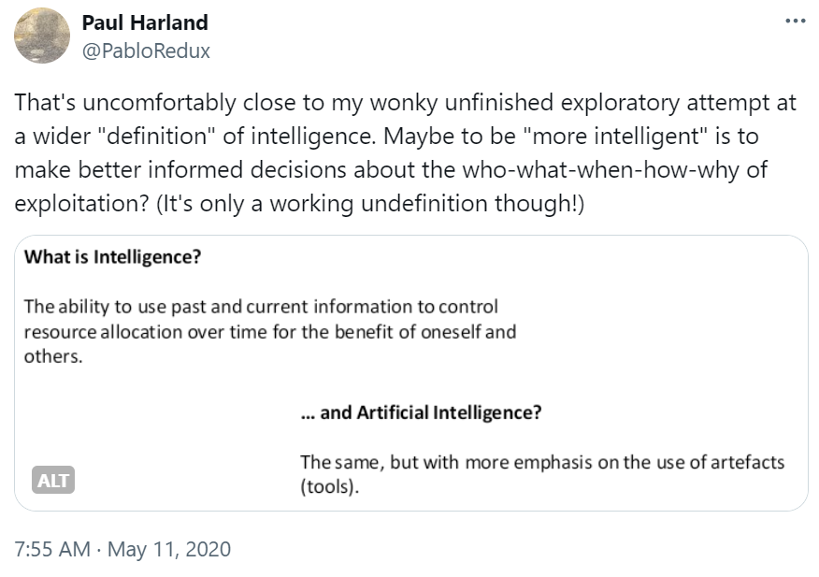

and making it more of a Suitsian game - perhaps I should've taken it further. But the coastline is always fractal.

Do we have enough examples yet for an undefinition of intelligence? No, but let's give it a try anyway.

It's the ability, while the outcome is still uncertain, to interpret past and current information in a way that allows control over available resources in a limited space and time for the observable benefit of an identified self or others.·

I'm conscious of this thread unfolding endlessly & fractally but there are now three areas I want to try to pin on the map: 3) a messy area, my messed-up essay on things-like-games (@suspendedreason); 1) a small point, about non-games vs games; 2) and in the middle, Sven's essay!

1st: 2)! @SvenNyholm's paper, both lucid & personal, discusses how Gamification (adding game-like elements to non-game activities, to encourage participation) might significantly change what those involved could be praised or blamed for, in relation to effects vs side-effects.

Now @JoshGellers referred to "epistemic and ethical imperialism". Things I wonder: could imperialism be seen as a game, and if so, what kind of game is it - who and what does it involve? But even if not a game, could one find evidence of (ir)responsible gamification(s) within it?

@JoshGellers

I think referring to imperialism as a “game” is reductive and inappropriate. It’s absolutely not a game in the sense that Danaher talks about in his book Automation and Utopia. Now, does the DISCOURSE surrounding imperialism constitute a RHETORICAL game? Perhaps.

@PabloRedux

I don't think it's necessarily reductive or inappropriate - potentially the opposite. And I feel when people talk about "playing the game" at work or, elsewhere, about "gaming the system", they are talking about activities within enterprises or nations that are not merely talk.

So, in my parallel replies in the thread with those 2 papers about imperialism, I was trying to scope out the kind of moves under consideration (if I get to pt.3). But also, @JohnDanaher's book, from a peek into online extracts, seems to be largely following Suits (my next pt.1).

@JoshGellers

Sorry but as someone who teaches development politics I think calling imperialism a mere “game” is fallacious at best and insulting to the lived experiences of the colonized at worst. Under your rubric, I guess ethnic cleansing and genocide are “games”?

@PabloRedux

If imperialism is a game, it would hardly be a "mere" game (to reverse your use of quotation marks). Nor would any fascistic narrative safely become a "mere story". For me, the offence lies in the nature of the game, the nature of the narrative. Does that make any sense to you?

@JoshGellers

Yes and I think you’re wrong. It’s not even mechanistically a game and to make the assertion is to trivialize its impact.

@PabloRedux

At least I never managed to finish that essay of mine, 'cos I'm sure if anyone who agrees with you had taken a chance on reading it, they'd have just seen it as moving through a muddled-up series of trivialisations - and it takes quite a lot of effort for me to be that wrong :-(

@PabloRedux [CONTINUING MAIN THREAD]

So here's a recent review that suggests possible differences between colonialism and imperialism https://journals.sagepub.com/doi/10.1177/00905917231193107 - the shifting history of the terms; colonialisation as practice, -ism as ideology; both -isms as 2 related ideologies; "internal colonialism" as "metaphor".

What about "internal imperialism"? This paper (from book) https://researchgate.net/publication/332466083_imperialism says, "In its contemporary form, imperialism represents an over-determined and contradictory relation between its ‘internal’ and ‘external’ forms through which global capitalism is made and unmade."

@SvenNyholm discusses a gamified vignette of companies competing over environmental prize money. If we simply decide not to call very similar activities a game, does this mean this other game didn't happen? 'Cos I feel I'm very much complicit in climate change through air travel.

It may be worth at least considering I'm being gamed (including by myself) or that my leisure may have been gamified without frequent flier and other travel rewards. I can't help wondering if my complicity in globalisation, past & future colonialism, etc, involves many games.

My perspective https://twitter.com/PabloRedux/status/1784497501397029332 could simply be mistaken but… Might it be possible to widen @SvenNyholm’s analysis to “non-games”, or near-games, to address our participation in a shifting sea of good & bad effects while doubting how to ultimately allocate praise & blame?

On to 1)! Suits contrasts “really being a game” with “as though it were”, although when applied to how to live one's life the distinction between literal & metaphorical readings is elusive. The question for me is: in what way are game-like non-games unlike games that are games?

Someone saying “you have to play the game” at work is not suddenly confessing their whole work life is a game, it's more like a brief stepping out of character. Perhaps there are modes of life that, whilst offering the elements of a game, generally aren't spoken of in that way.

Perhaps there are no examples and again I’m mistaken. But (perhaps to me only) it’s an interesting possibility: that there are games we're willing to acknowledge as games and others where, for whatever reason, denial is preferable. Perhaps for other concepts too? Or perhaps not!

PS - maybe this should've gone under (2) - game leaders would also seem to play some of the role of designers, more so in informal games, in leading others (including themselves) to act in certain ways...?

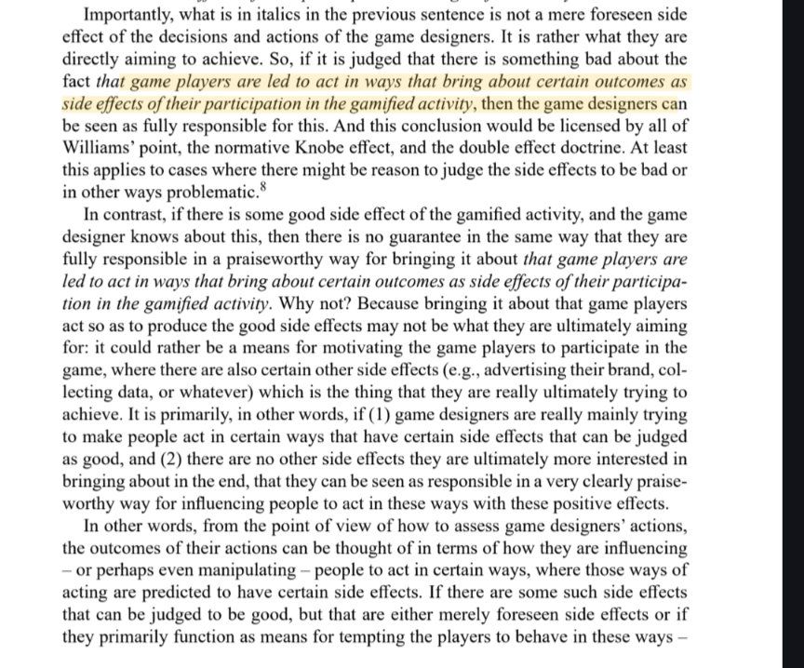

3) I think my Last Post essay got stuck at the right place - having reflected on Sven's paper, David and Josh's comments here (and thinking through Hohfeld again in their chapter on AI & International Human Rights Law) and @add_hawk's work including Forms & Fluidity of Game Play.

@suspendedreason

Link to Last Post essay?

@PabloRedux

There's a chunk earlier in this thread but I got stuck and gave up on it.

It's hard to formulate the questions: where do events happen; and where again, in our words and our thoughts; and, yet again, what if they're not in our words or thoughts; and where does the process ever stop? Was that the problem, on top of the other problems I find in writing?

I can't answer that here (or probably anywhere) but, pragmatically, we might describe events at the around-human level as a superposition of patterns. Neoliberalism might align most human activities with patterns of market behaviour, e.g. students as customers of universities.

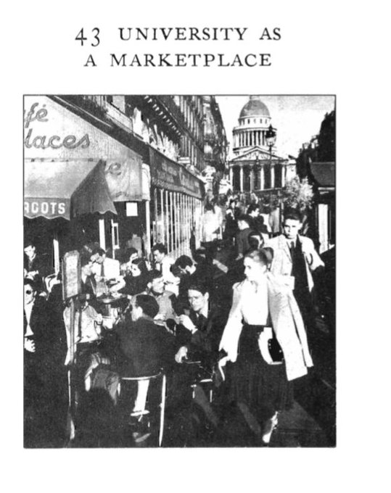Finally, how should a university marketplace be administered? We don't know. Certainly a voucher system where everyone has equal access to payment vouchers seems sensible. And some technique for balancing payment to class size is required, so teachers are not simply paid according to how many students they enroll. Furthermore, some kind of evaluation technique is needed, so that reliable information on courses and teachers filters out to the towns people.
There are several experiments going forward in higher education today which may help to solve these administrative questions. The Open University of England, the various "free" universities, such as Heliotrope in San Francisco, the 20 branches of the University Without Walls all over the United States, the university extension programs, which gear their courses entirely to working people they are all examples of institutions experimenting with different aspects of the marketplace idea.

Interestingly, in A Pattern Language, this vision was presented as a positive pattern, a sustainable mode of life within a community, but many of us might see it now as an anti-pattern: <https://en.m.wikipedia.org/wiki/Anti-pattern> Perhaps activities we hesitate to call games are also anti-patterns?

I think "life as a game" is more defensible and flexible as a meta-pattern than alternatives such as seeing society as a vast networked market, especially if one allows that games can have the qualities of anti-patterns. Perhaps this is why we feel ambivalent about gamification?

Our default mode is mind-wandering, to be at play. Switching to task mode, we're "in play". Games articulate tensions within us of postponed self-contradiction: necessary unnecessary, cooperative competition, make-believe striving (thx @add_hawk: Forms & Fluidity of Game Play).

We can see that tension in human rights <https://plato.stanford.edu/entries/rights/#AnalRigh> - in the "correlatives" (e.g. rights & responsibilities) and the disputed territory of will vs interest theories (thx @David_Gunkel). I feel we could expand Hohfeld's incomplete analysis into rights-as-a-set-of-games?

War, as a field for "games", must be the archetype of anti-patterns, @JoshGellers? I've chosen this article over several others mainly because it claims "genocide" in relation to "calculations of legitimate proportionate violence" <https://bylinetimes.com/2024/04/12/collateral-genocide-inside-israels-official-legalisation-of-mass-civilian-killings/>

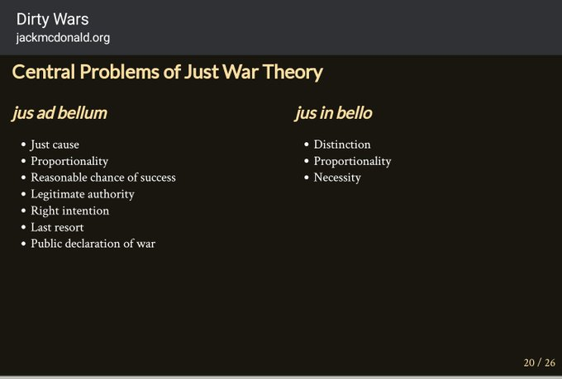 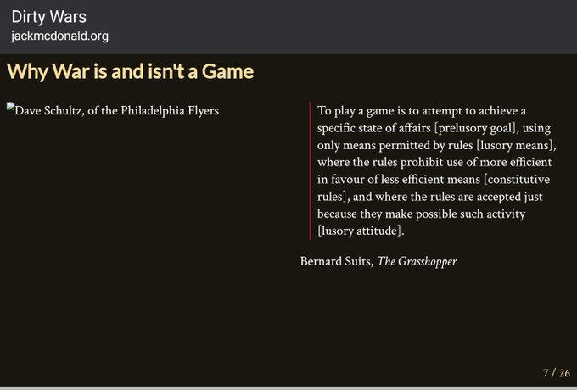

@JoshGellers

At the risk of excessive conceptual stretching, I think under this line of thinking virtually any game-theoretic act could be seen as a “game.”

@PabloRedux

Well, it does feel a little bit of an anti-theoretic move.

War may have become gamified and/or open to gaming in this scoring of "collateral damage" to select targets (with the increasing participation of machines) in what may be a perverse reading of Goodhart’s Law: “When a measure becomes a target, it ceases to be a good measure.”

I feel these kinds of considerations may bring some of the most violent events within the scope of @SvenNyholm's paper - Gamification, Side Effects, and Praise and Blame for Outcomes - or at least into a ghastly parallel universe with its own responsibility black holes.

Sven even mentions "military ethics/just war theory" under Double Effect. As a reader with my current views, I have to accommodate war "games" in my reading. https://twitter.com/pabloredux/sta/PabloRedux/status/1784497501397029332?t=N7wowTSYTwnM9ZNEIRzzFw&s=19 But the conditions of war overflow with ambivalent morality: praise versus blame is complicated.

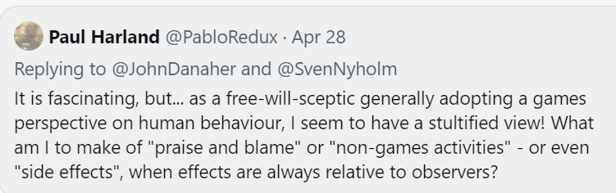

In some ways the corporate world is a more "relaxed" version of the military one, so similar complications may arise. In my experience, prizes and praise may be awarded against corporate targets where ethics is only an accidental component, typically to meet external obligations.

In the paper's example of developing an environmental product, it's quite possible some employees may go beyond an indifferent CEO and personally be climate change deniers but still try to come up with the best product, given other positive or negative company incentives.

Actually, does the paper mention negative incentives to encourage participation? At the extreme, I doubt British mill-workers' involvement in slavery on cotton plantations was voluntary but similar workplace questions still arise, although often obfuscated on a day-to-day basis.

@SvenNyholm

If you are referring to my paper, no, it does not. I was interested in positive incentives (rewards, positive reinforcements, etc), which I think are much more strongly associated with the idea of gamification of the sort that tends to be used in apps and so on.

@PabloRedux

But it may "stimulate further discussion"! Your use of company examples reminded me of my reflections on being involved in competitions and other schemes. More generally, one motivator is FOMO (Fear Of Missing Out): https://yukaichou.com/gamification-study/8-loss-and-avoidance/ E.g. "performance related pay" being as much stick as carrot.

@JoshGellers

To Sven’s point- if everything is a game, nothing is a game. War can have game-like aspects, but calling it a “game” trivializes it. As I alluded to earlier, there are even some horrific crimes that, under Paul’s interpretation, might be considered “games.”

@PabloRedux

If war, horrific crimes or even crimes in general are (arguably) all game anti-patterns, this at least allows us to consider for a moment, for instance, what kind of "lusory attitudes" have somehow come to be accepted or tolerated within those "games".

The "if everything is then nothing is" argument is a reasonable worry about an unthinkingly empty relativism. But it may lead to worries such as that the mere idea of "robot rights" trivializes rights rather than helping us to understand what forms of rights we already live with.

@JoshGellers

I see these as two completely separate issues. As the sage @David_Gunkel once remarked, “rights for robots is less about the rights of artifacts and more about the artifact that is rights.”

We already know what rights we live with- the ones specified in law.

@PabloRedux

I agree more with the first statement than the second. We do have an awareness of the artifacts of rights that we come into contact with through legal systems, but we may feel some moral rights are poorly accounted for there. And there may also be rights-like events beyond both?

Lazy reworking from 2nd para of https://plato.stanford.edu/entries/rights/: To acknowledge some kind of rights is to gain an awareness of potential or actual distributions of freedom and authority, and to at least be prepared to reckon with a certain view of what may, must, and must not be done.

From my perspective, I'm interested in understanding the incentives to engage in the persecution of so many subpostmasters: https://en.m.wikipedia.org/wiki/British_Post_Office_scandal What factors were in play that enabled the slide into illegitimacy of a state-owned private enterprise providing a public service?

This looks to me like gamification: https://independent.co.uk/news/uk/politics/post-office-inquiry-money-targets-b2483273.html One must in addition consider that hierarchies do not always document aspects of planning that may not read well to outsiders. See Eichmann's comments on "office language" in the Wannsee Protocol: https://en.wikipedia.org/wiki/Wannsee_Conference

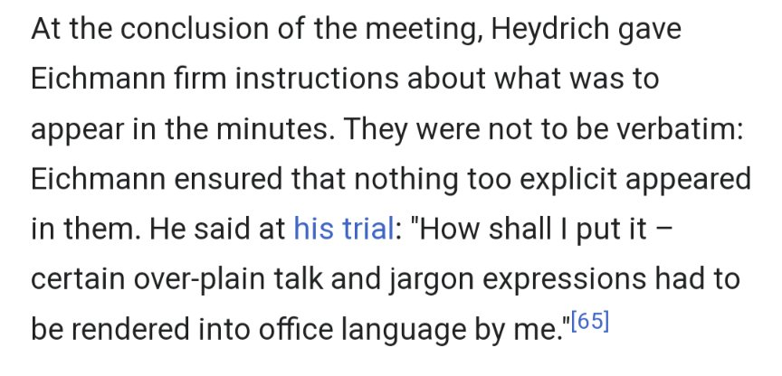

The stated aims, rules & roles of a “game” may not reflect unethical unrecorded versions, lost to the record unless an enterprise ends up in court. In practice, the examples in @SvenNyholm's paper of environmental challenges may well include instances of “greenwashing”.

But even if not deliberately misleading, game-like elements may be subject to vagueness - https://plato.stanford.edu/entries/vagueness/ - including gradually shifting over time. From my perspective, I would have to include games where some aspects were borderline.

Less intangibly, it might be productive to explore lotteries, which have been run as rackets (the “numbers game” https://en.m.wikipedia.org/wiki/Lottery#United_States ) but also supported more worthy causes. By varying the numbers, one could experiment with the praise/blame equation.

Rather than suffer me twittering through lottery permutations, here are some delightful moves from an old trouper... https://twitter.com/DancerOnFilm/status/1748042574978548102

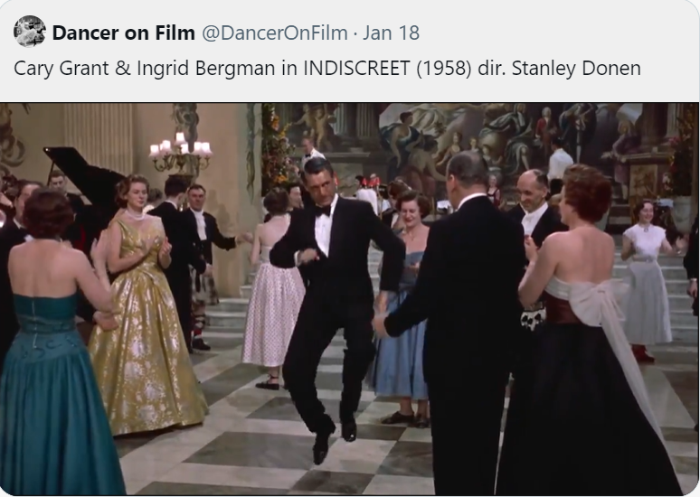

But if the medium's the message, charitable lotteries: promote gambling addiction and acceptance of massive individual wealth through sheer chance; turn candidates for public services into a lottery; collect for charity inefficiently, returning money or siphoning off as profit.

But there's loads more to play with! These soccer-promotion crisp packets, if they cost a penny more, would be an illegal lottery, but at least you can watch sports sitting in the pub while tempted to consume some extra fat. And salt - need another pint after that.

 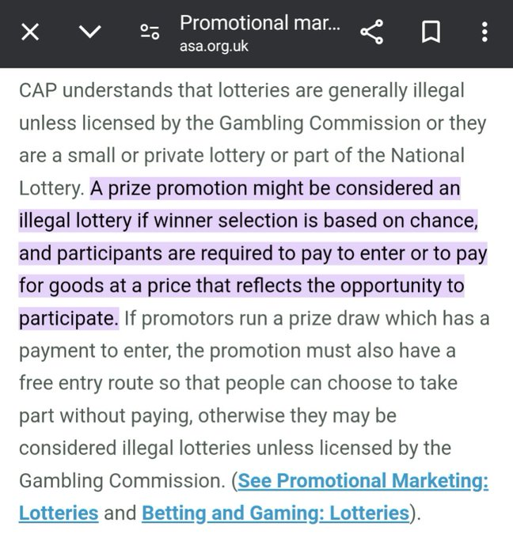 

What's interesting about Sven's paper is, even for a free-will-sceptic like me, it suggests a means to explore how people's attributions of praise- or blameworthy activity may be accidentally, deliberately and/or incidentally "gamed", through explicit or implicit "gamification".

I was going to restrict this rambling commentary to just 2 or 3 more points but fortuitously (for me, sorry!) someone [Yes you, @BEER_Wiley!] has liked David's reply https://twitter.com/david_gunkel/s/David_Gunkel/status/1190621072573513731 in my 2019 thread. That article and thread seem to have a few useful pointers or reminders before my final points.

*@David_Gunkel, Nov 2, 2019*

*The question of corporate character and virtue does render many aspects of this discussion much more complicated than they initially appear to be. “Corporate character, corporate virtues” by Geoff Moore, 2015: https://onlinelibrary.wiley.com/doi/abs/10.1111/beer.12100*

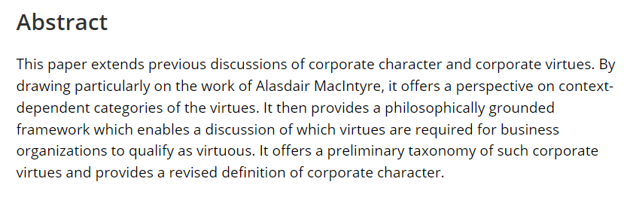

@PabloRedux

Sven's paper talks of the "game designer (e.g. a company or organization)" but later, as far as I can see, uses the example of a person, the "CEO of a company", so not corporate responsibility (including praise vs blame for an org itself). This [DAVID’S SUGGESTED PAPER] helped me: https://durham-repository.worktribe.com/output/1436025/corporate-character-corporate-virtues

One may conceive of praise & blame as perceptions of virtue & vice, which may attach to a culturally-evolved structure such as an org as well as a person - but also the particular virtues & vices which we see may be to some extent culturally-evolved as well as individually felt.

One may also view further containing and/or associated structures as tending towards good or bad, e.g. the mixed feelings people have (presumably more acquired than innate?!) about capitalism. Moore (in the article David shared) finds a conceptual framework in Alasdair MacIntyre.

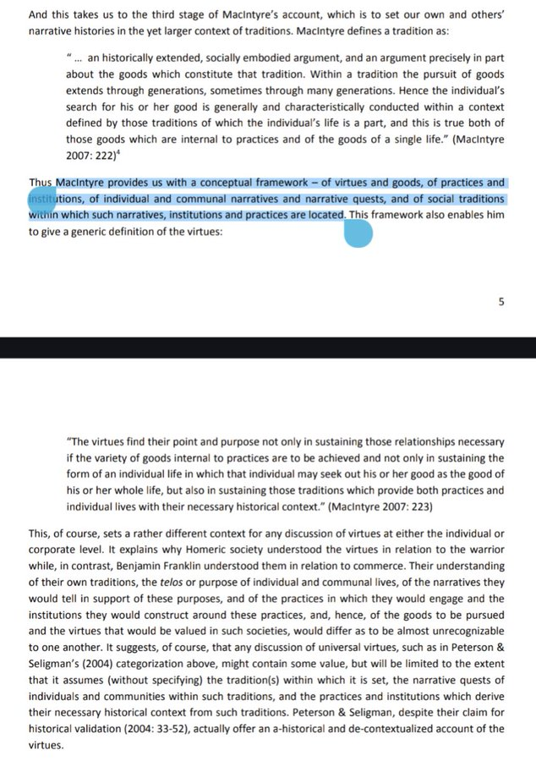

I believe a narrative approach, including gestures as implicit speech acts, usefully positions us as moral agents - it's a natural, psychologically, for our species - while communal narrative and meta-narrative support ethics. Seeing the drama/performance foregrounds interaction.

Sidenote: MacIntyre's "The unity of a human life is the unity of a narrative quest" made me think of folk tales, Star Wars and the 70's Fortran Adventure game. (Even mentions side effects @SvenNyholm!) But my idea of lives and narratives in them is that they're quite fragmentary.

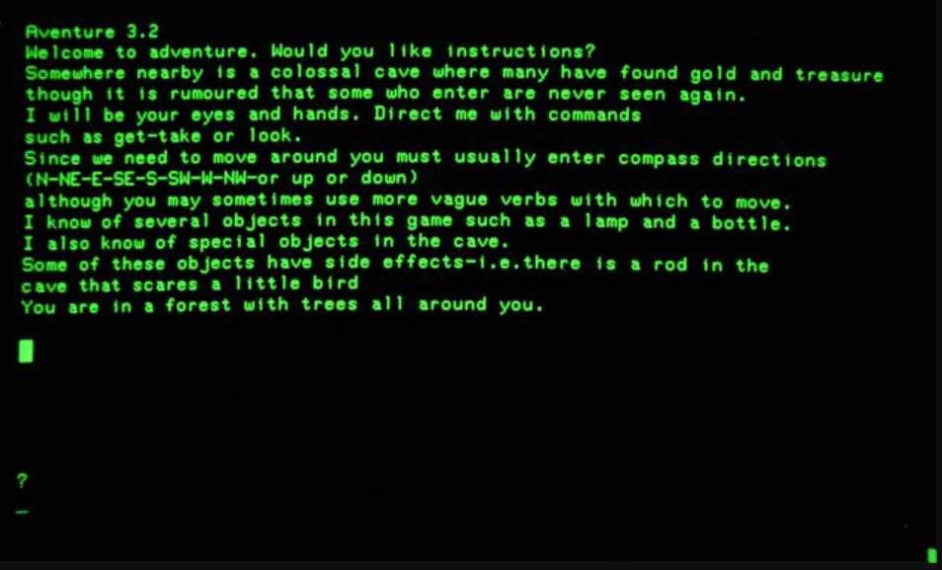

However, a "game" framework, I would suggest, is sometimes more expansive and more neutral. It allows unintentional or completely unconscious participation in others' "games", whether formal or informal, including forms of "game" that have become traditional or institutional.

An organisation might be a partly unconscious (certainly "qualia"-free) actor in ethical aspects of a game, a robot entirely unconscious (unless added by design): https://sciencedirect.com/science/article/pii/S0040162523000616 And we may sometimes participate without being as conscious as our ideal selves would prefer.

So I think Sven's essay, his prying into the philosophical gaps, returns us to the areas covered in his footnote 2 (or as seen in "Entertainment vs. manipulation: Personalized human-robot interaction between user experience and ethical design", link above) from a fresh angle.

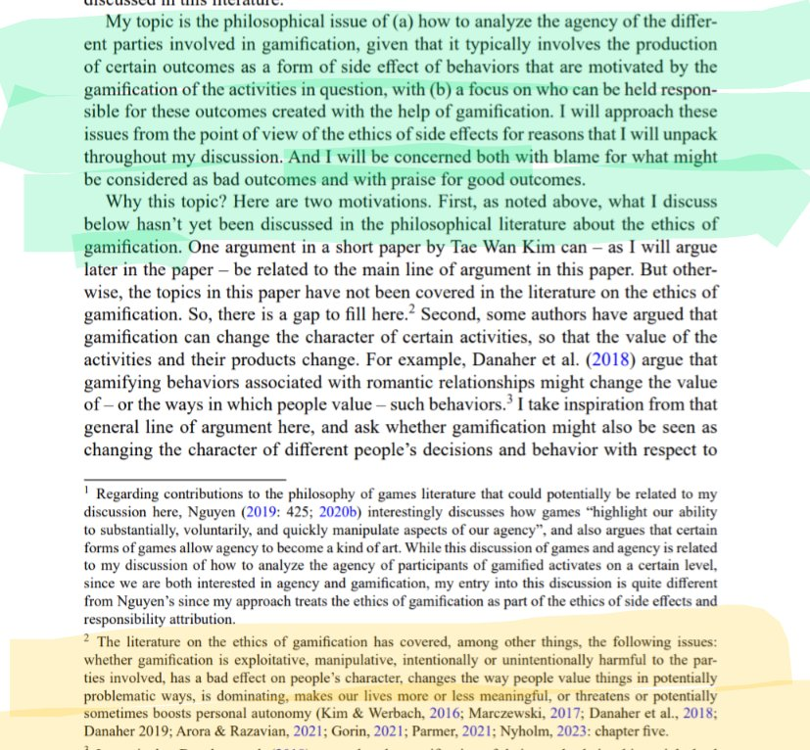

So I think that was my point 1 of the 2 or 3 remaining. It seems a productive method, moving beyond the specifics of lotteries and other examples, of metaethical digging into the field of ethical games. And I'd be interested to see how far one can reframe life in terms of games.

@JoshGellers

Why? Why risk trivializing certain serious issues just to fit a convenient frame? I’ve been alluding to several terrible examples of this, so I’m more interested in setting limiting parameters rather than treating everything like a game.

@PabloRedux

I doubt anything's at risk from my armchair noodling. But I imagine everyone's way of facing existence shapes their wider views. As a recovering nihilist, the frame is not convenient but not inconceivable. I'm trying to make sense of a world that perhaps appears different to you?

@JoshGellers

I suppose what I’m saying is that following your argument to its logical conclusion would result in some ethically problematic comparisons. So the question is why even go there?

@PabloRedux

I'm trying to come back from nothing, which is already ethically problematic! You and David often seem very near to my perspective, introducing me to works I can relate to - except, in my experience, losing the distinction between myself and my surroundings can feel pretty bleak.

So I do have an interest in trying to understand how others differ from me - when I look around, I guess everyone just starts from where they are? To live, I suspect we all accept some things with unreasonable faith - one thing for me, obviously, is that anything matters at all.

Possibly the current version of me physically experiences more difficulty than you, Josh, in finding the boundaries between words, ideas; between me and a murderer (maybe I'm already one but the circumstances haven't yet arisen) or me and a cat: *“Sep 2, 2016, Watched the kittens' random attention switches, felt superior, sipped tea, looked around for something else to briefly catch my attention.”*? Or a bat.

I do feel somewhat embarrassed about the expanding length of this thread but... at least the difference between readers in experiencing a work that touches their interests was my concern at the outset:

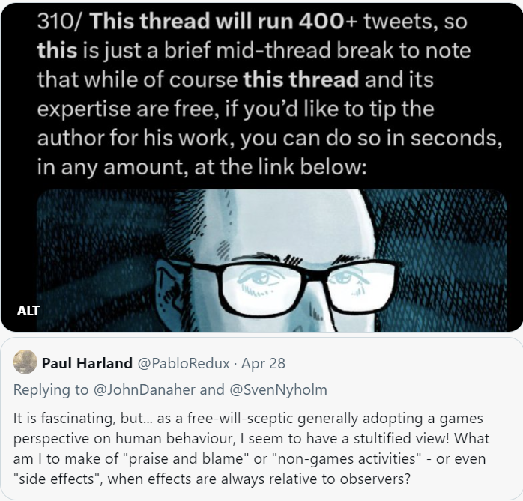

Unfortunately, Sven's focus here interests me a lot!

I think even in reading a text we can experience an affront (this is my reading of David reading Levinas) in the encounter, from within our lives, within theirs and across the divide, between lived readings. Which somehow will have to serve as the intro to my penultimate point.

The ethics of writing - what (if anything) to say, to set in front of others? - turns an author back towards their own words and the life put into them. ("Why bother...?" I must be ignoring that inner voice to continue affronting you in this thread. Hopefully I'll wrap up soon.)

Sven inserts himself into the topic of his paper by talking about his own use of a gamified running app, but resists advertising the name of the brand. However, when discussing the ice-bucket challenge, he makes sure to share info about ALS plus a link to https://als.org/understanding-als/what-is-als.

And I've just repeated his choices, but it's interesting (at least to me) that in a paper about the ethics of gamification side-effects he doesn't note them - perhaps because the point is too slight or it might look like self-praise or it draws attention to the act of writing?

(I must confess that when I first read the article, I did overlook the sad dedication in the Acknowledgements. Sorry, Sven.)

Perhaps it would also have invited comparative blame for other authors who had used the ice-bucket challenge in their thought experiments while failing to share information on the disease? Should thought experiments require ethical approval...? (See Protecting Participants in Thought Experiments: The Role of the Research Ethics Committee by David Shaw, 2018: <https://doi.org/10.1007/s11673-017-9831-8>.)

Sven's paper creates a further possibility for reflexivity when he briefly discusses the idea of the gamification of academic research, but doesn’t follow it up, in spite of using himself as the only reference - which, to me, ironically reinvokes the unacknowledged possibility.

Anyway, that led me to this Jan '24 Frontiers review article by Köbli et al https://doi.org/10.3389/fcomm.2024.1323867 which looks at the rise of "academic publishing as a game", e.g. through "marketization". Of course, one could also trace their themes backwards through earlier generations.

So, their heading "3.3 Side-effects of the game: unethical behavior and predatory publishing" prompts us to remember older violations of "scientific standards and integrity" motivated I imagine by the traditional rewards of advancement and attention: <https://en.wikipedia.org/wiki/Cyril_Burt>

I was also thinking of the way AI researchers were always claiming to come up with an algorithm that outperformed all the other algorithms on some benchmark. It had almost become an end in itself. If the metaphor was the message, then the (undebated) moral was: "more is better".

Doing a quick search now, the field seems a bit more self-aware: some unintentional side effects of these pursuits are being discussed and measured. <https://twitter.com/elie/status/1797038989624410294>

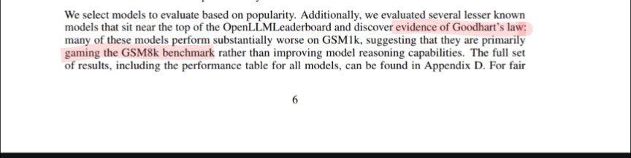

*Quote: Elie Bursztein @elie*

*[Weekend Read] A Careful Examination of Large Language Model Performance on Grade School Arithmetic:* [*http://arxiv.org/abs/2405.00332*](http://arxiv.org/abs/2405.00332) *By creating from scratch a new math benchmark (GSM1K) the authors show that many models training data are likely polluted with benchmark data. #AI #LLM*

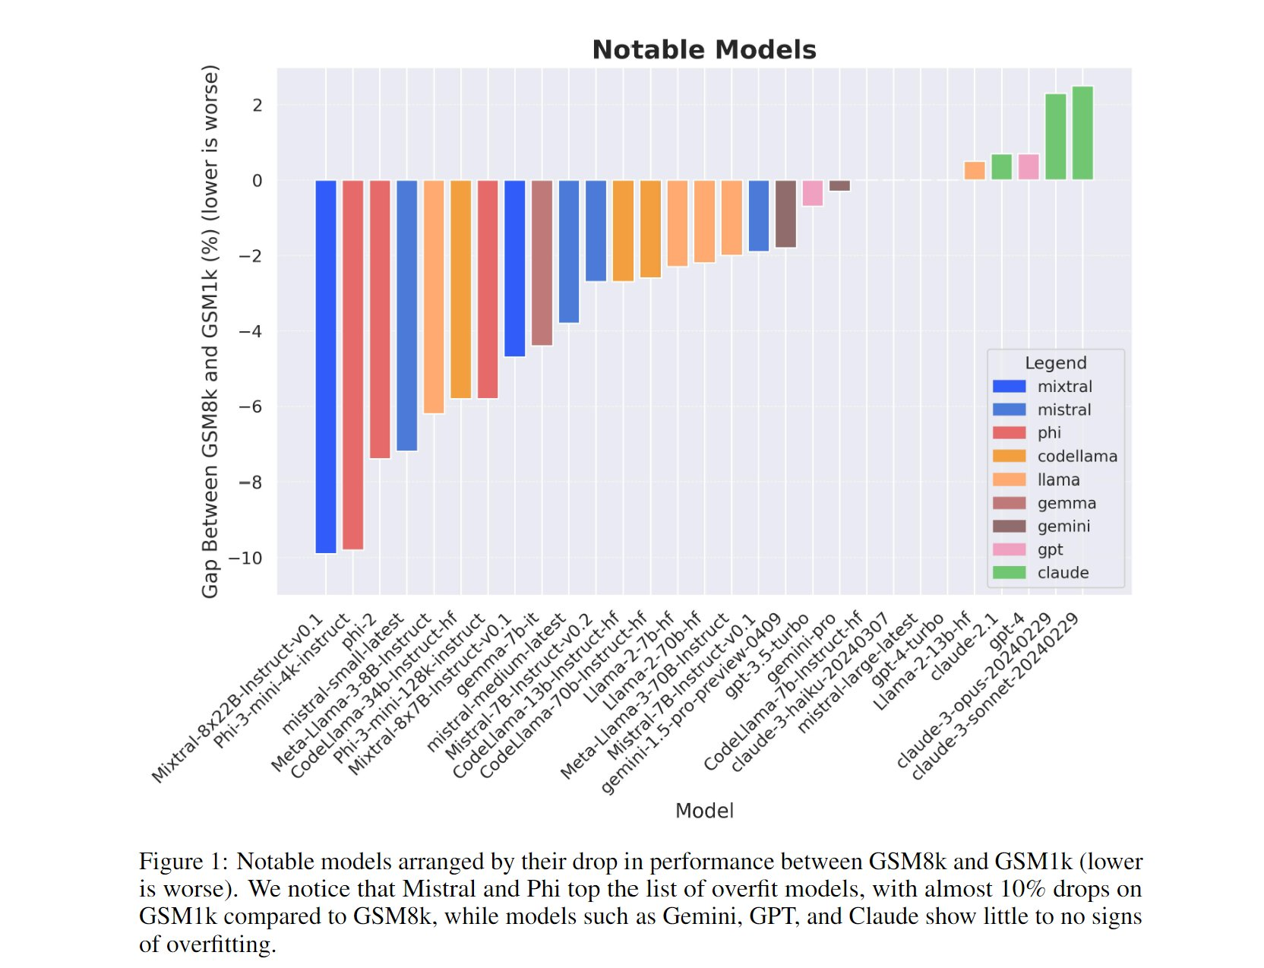

@PabloRedux

I looked up one of the refs, Llemma: An Open Language Model For Mathematics (Z Azerbayev et al, 2024), to see if ethics now gets a mention. Yes! They got advice on ethical considerations of model development & release. And data collection had an informal internal ethical review.

Going back to the LLM performance-examining paper for a moment, it seems adding a reward function is almost intrinsic to working with intelligence, whether it's the models or the testers or offering snacks to puzzle-solving corvids and bees. And it's coming up to teatime for me!

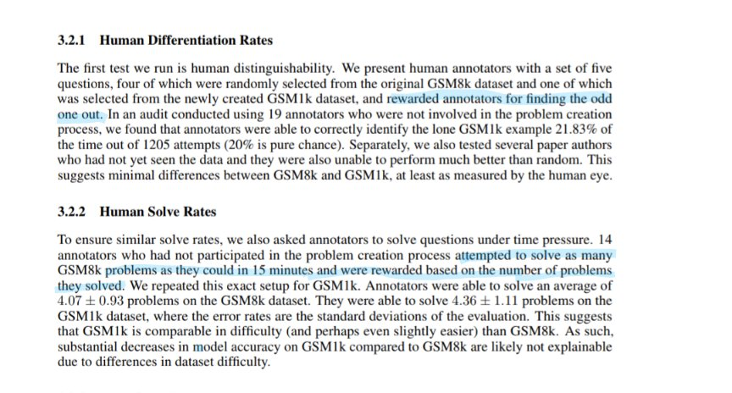

Finally, I've got to the end of Sven's paper. Or a little beyond... Acknowledgements (thanks and dedication), Funding (including Open Access), Conflict of interest (none) and "Ethics Approval: Does not apply. This is a purely theoretical paper."

I'm really not so sure. Even thought experiments based on real-world examples can have ethical angles. Some theories could have potential side-effects we disapprove of. And academic papers may game the rankings and so on. I'm not trying to be comprehensive, just expressing doubt.

What is and isn't discussed helps shape culture; what seems (un)necessary to discuss reflects culture. And we begin to see those technical AI papers feeling they have to justify themselves a little more. Sven's text perhaps selects or accepts unstated rules of good or bad form?

@SvenNyholm

No one has read the paper as carefully as you Paul! We might not agree on all points but I very much appreciate your engagement with my paper

@PabloRedux

Cheers! I'm just trying to make sense of a view of the world that is less https://plato.stanford.edu/entries/game-ethics/ and more like the non-explanation at the end of this scene from L'Age d'Or https://youtu.be/E9AdusKTUl0?feature=shared&t=2050 Can anyone recommend a good book...?

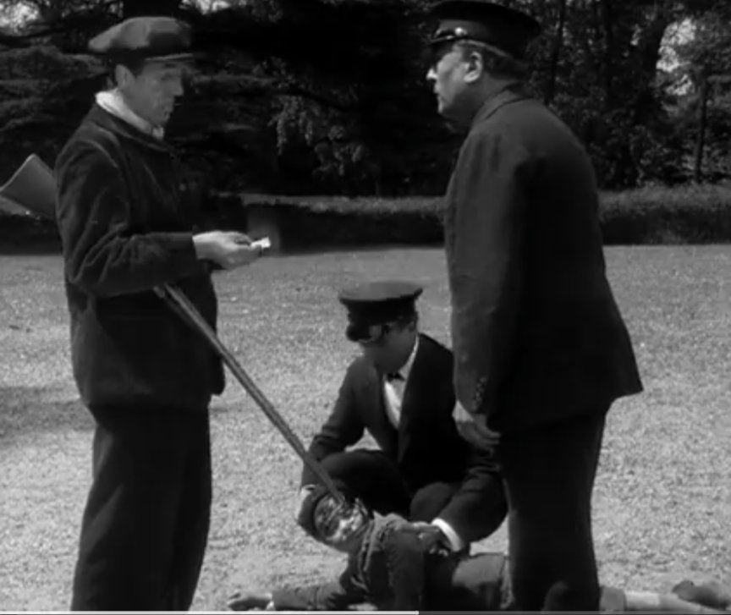

Clues, perhaps, in this off-handedly well-read reading of "On Latour’s An Inquiry into Modes of Existence: Are there 15 ways to be unhappy?" https://poptheory.org/2014/03/21/are-there-15-ways-to-be-unhappy-surfing-bruno-latours-an-inquiry-into-modes-of-existence/ by Clive Barnett RIP https://covidresponsibility.org/2021/12/27/geographies-of-generosity-remembering-clive-barnett/ For sure "Games: Agency as Art" https://blog.apaonline.org/2023/10/06/recently-published-book-spotlight-games-agency-as-art/ by @add_hawk



I could really dig the writing-of-the-book piece. I feel it - although of course I've only ever failed at it. I can get behind the conclusion too, as it fits quite well with my concluding point - oh dear, by my count I still have point number 3 of the "2 or 3" I had left, sorry!

But the most moving response was a letter from a student, who’d heard me give a talk about games and gamification. She gave me permission to tell her story, and I’m going to tell it in more detail in the popular book I’m writing right now. She said that my talk had pulled her out of a five-year depressive tailspin. That, she now realized, she’d been caught in bad games – obsessed with grades, obsessed with athletic success, obsessed with her weight loss. And that I’d given her the frame and language to think about those things as bad games, and realize that she had some significant choice in whether or not she wanted to play them.

Anyway, that response basically justifies my entire life.

So I'd like to suggest to @add_hawk, for a moment, that activities like dancing freely are still more gamelike than... not. Keeping in time, perhaps to a simple rhythm in our heads, can be made less demanding than climbing over obstacles, the moves far less consequential, but...

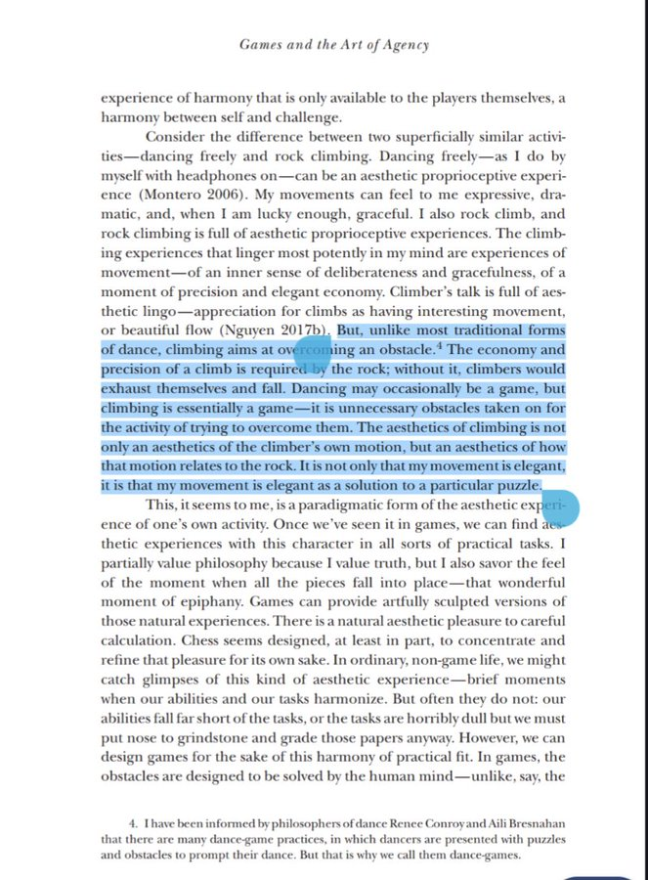

... could also be made very challenging. But one may simply choose to compete badly with oneself! Still, throwing out moves in patterns within one’s chosen constraints is a stupidly inefficient way of getting from A to B, a "voluntary attempt to overcome unnecessary obstacles".

Instead of trying to define what a game is, or puzzling ourselves over what a game isn’t, let’s look at what absolutely isn’t a game. Ungame, antigame, non-game have all at times been used to describe near-games. We need to move beyond the ungamelike to a state of gamelessness.

@David_Gunkel

They tried this in the mid-1970's.

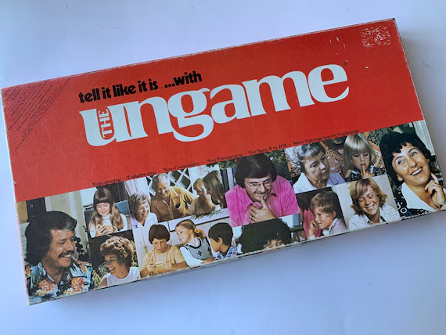

@PabloRedux

I couldn't find a non-game word that hadn't been gamed! https://polytechnic.co.uk/blog/2020/05/calvin-and-hobbes-and-quarantine/ As for the reference to one-upmanship, it's true - I'd barely found my way to the local library (when Britain had them) before I'd been cheated out of more wholesome ideas of games by Stephen Potter.

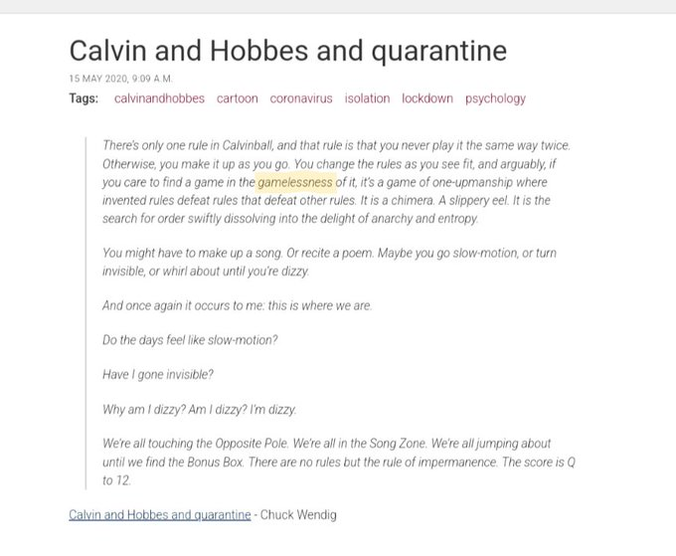

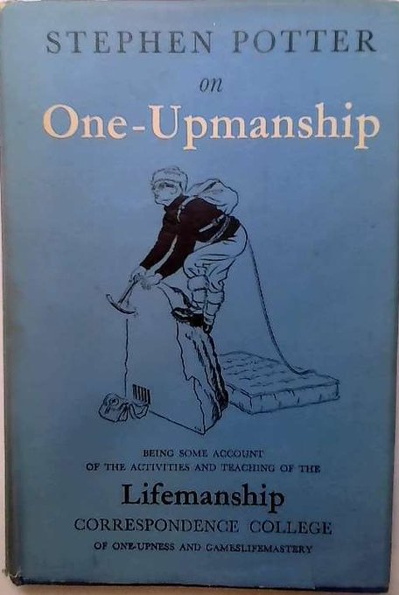 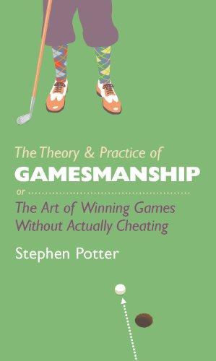

Getting efficiently from A to B to satisfy an overwhelming thirst looks like a paradigmatic case of gameless action. There’s no attempt to follow conventions, succeed through familiar patterns. Unless, should satisfaction be delayed, we kid ourselves along in order to persevere.

We can blame evolution for selecting our species to baffle with these problems. Gamelessness becomes the background uncertainty of spaces between games. The field of games is not uniquely human but we're much better than, say, bower birds at writing it up: <https://blogs.cornell.edu/info2040/2016/09/10/24865/>

What gets me here @JoshGellers is less the game-theoretic aspect than the birds' conscious engagement in all the necessary unnecessaries of bower-world. But for humans, tensions between conscious & unconscious, intentional & unintentional, artful & artless, are in lifelong flux.

Words and ideas are confounded by their own success in proliferating. They're said to lead double lives as metaphors, although the relationship is probably more involved than that. In French, I believe, the jeu in "La Règle du jeu" would not refer to the "game" in the hunt scene?

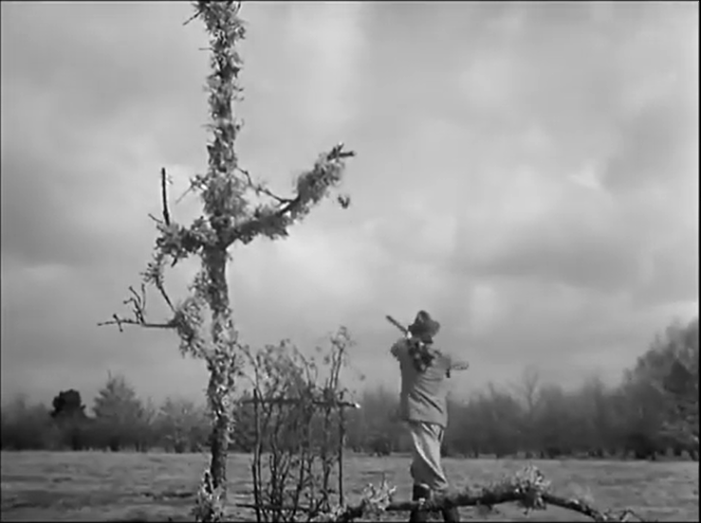

Although it might refer to "manner of handling a gun" https://en.wiktionary.org/wiki/jeu#Noun All very interesting, but I think I need to get back to the point here!

A quick way back is to remind ourselves what Wittgenstein said about what 'a game' was - https://magne.medium.com/what-did-wittgenstein-say-about-what-a-game-is-d333383cf8b4 - while remembering he would have said Spiel.

I think what Wittgenstein was still trying to figure out there could get us somewhere. And here, across just a few pages in this Foucault Reader, you see Foucault in the midst of rethinking and then succinctly observing intersections of human bodies, society and complex systems.

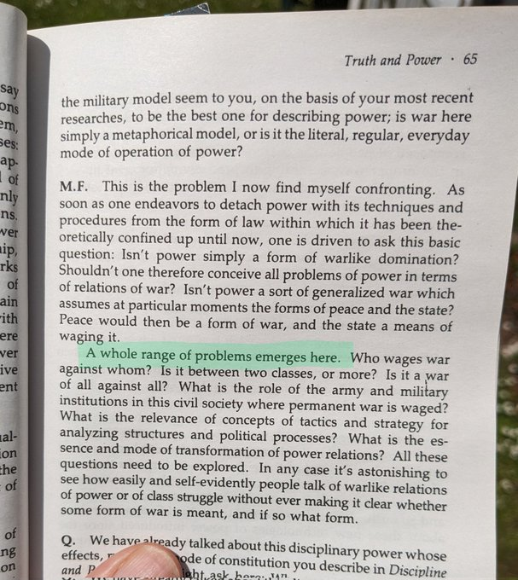 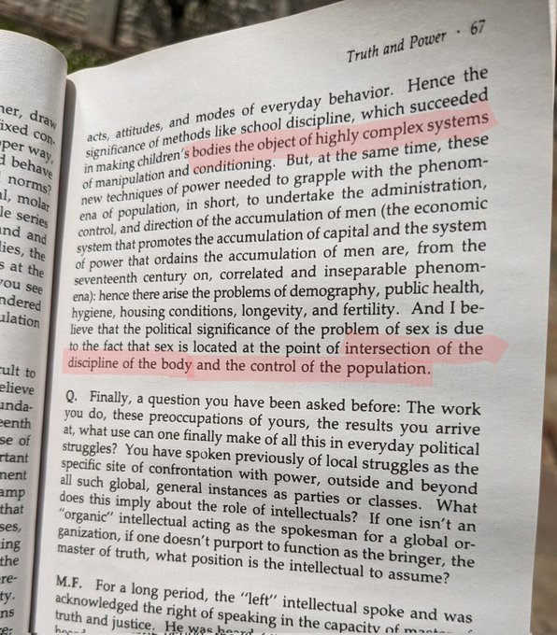

Game worlds emerge at life scales, where systems tend to evolve “family resemblances” to games. When ripe, such worlds spawn participant-observers who begin to develop sets of conventions amongst natural “laws”. These agents are decentred, sharing the field with the other pieces.

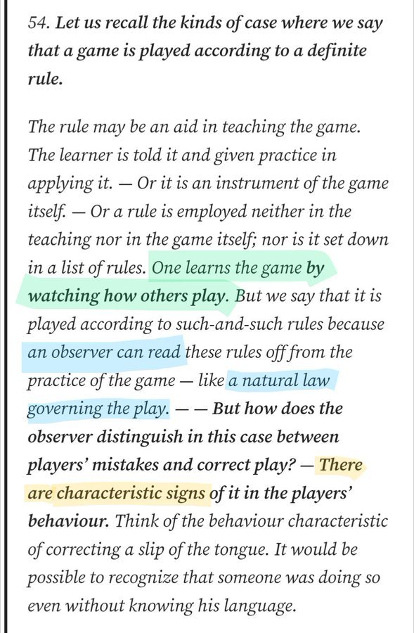

Moves can be forced, accidental, judged good or bad or even cheating. @JohnDanaher offered for my consideration Sven's “Gamification, Side Effects, and Praise and Blame for Outcomes”. Moves certainly have effects & side-effects but, in a game, in principle, only within that game.

Without the insight and diligence of Foucault-like observers, we may fail to notice further overlapping games. Our bodies may participate, but we've become so habituated that, when it's pointed out, we're as surprised by the discovery as the audience of an on-form stand-up comic.

C Thi told us about a student discovering there are bad games (anti-patterns). I don't need to believe in free will to be sure that being presented with fresh ideas about games and gamification can create previously-unheard-of options for an audience. Including to buy his book!

I haven't quite said enough about side-effects. There are effects & side-effects within a game, and of the game. It's never a closed system, there's always overspill (as well as internal leakage). Side-effects of chess spill into our personal lives, into events, books & machines.

I haven't quite said enough about side-effects. There are effects & side-effects within a game, and of the game. It's never a closed system, there's always overspill (as well as internal leakage). Side-effects of chess spill into our personal lives, into events, books & machines.

To return to Sven's paper, and where I started in my reading of it, how responsible are we for the games we play or find ourselves playing (once somebody has pointed it out)? I don't know, but I really appreciated the chance it gave to play with ideas. Any suggestions anyone? x P

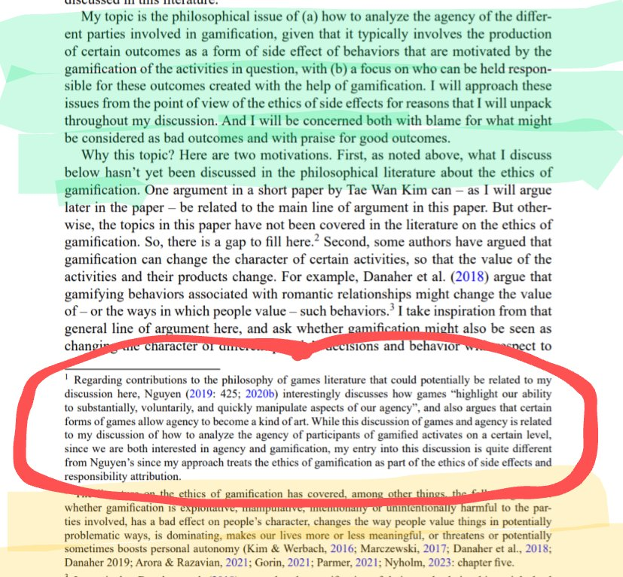

***DRAFTING***

**PUT BEFORE THE PS:** 3) It seems like I am, so I must be? Language, an extended embodied tautology, reflects our not-uniquely-human condition: one of many more or less conscious animals, temporarily set loose in our surroundings, re-encountering ourselves amongst possibly similar others.

I'm having trouble getting past the nebulousness of events https://plato.stanford.edu/entries/vagueness/ including in my mind. The only reassurance here is it's complicated: https://plato.stanford.edu/entries/concepts/ So how to deal with that pragmatically? https://plato.stanford.edu/entries/pragmatism/#PragMaxiPeir

Our default mode is mind-wandering, at play, until, switching to task mode, we become in play. Games articulate tensions within us of postponed self-contradiction: necessary unnecessary, cooperative competition, make-believe striving (Forms & Fluidity of Game Play, by @add_hawk).

A single language game may seem to box a word into a defined space but with every repeated game it continues to evolve, all the while carrying on a double life as a metaphor.

With words we seek to put a label on events before they can get away, never to be encountered in that exact form again. Concepts cannot keep themselves to themselves.

Which are in one way or another always unrepeatable.

In the moving crowd, narratives find their voices; drama enlivens the action taking place; games bring variation and uncertainty.

Language pulls both away from and towards metaphor. Justice is violence. Doublespeak. War is, kind of, a kind of game; games are a kind of war.

Words are containers, spilling as they’re carried away. Metaphors. Oxymoron.

Words, the labels we slap on whatever passes in front of us, are only leaky containers, held together by the elastic of metaphor.

Words create categories to be abused.

Words are labels slapped on a world passing by.

Words are labels slapped on the world going by and travel where they may or pull apart.

Our concepts are focused on our own increasingly complex social systems.

Language reflects our psychology and circumstances. Already include make-believe, counter-factuals.

I NEED TO GET ONTO LOTTERIES, ENDLESSLY VARYING THE CIRCUMSTANCES, AND ETHICS…

But even if not deliberately misleading, game-like elements may be subject to vagueness - https://plato.stanford.edu/entries/vagueness/ - including shifting over time. From my perspective, I would have to include games where the game aspects were borderline.

https://www.frontiersin.org/articles/10.3389/fcomm.2024.1323867/full

It seems to me this plays fair by both the rules of the academic world and the original charitable cause, but as two separate ethical games, or modes of life, in one space. No ethical approval is required for what happens in thought experiments: <https://link.springer.com/article/10.1007/s11673-017-9831-8>

“Ethics Approval. Does not apply. This is a purely theoretical paper.” One that discusses the ethics of gamifying a challenge raising awareness of a degenerative disease (link given in paper <https://www.als.org/understanding-als/what-is-als>) by targeting those (in theory) seeking social media attention.

This may seem trivial but, having looked at more than a few technical AI research papers over the years, collectively they felt very ethics-lite: more concerned with what’s cool in the lab than with how it may turn out later, there being no requirement to consider that question.